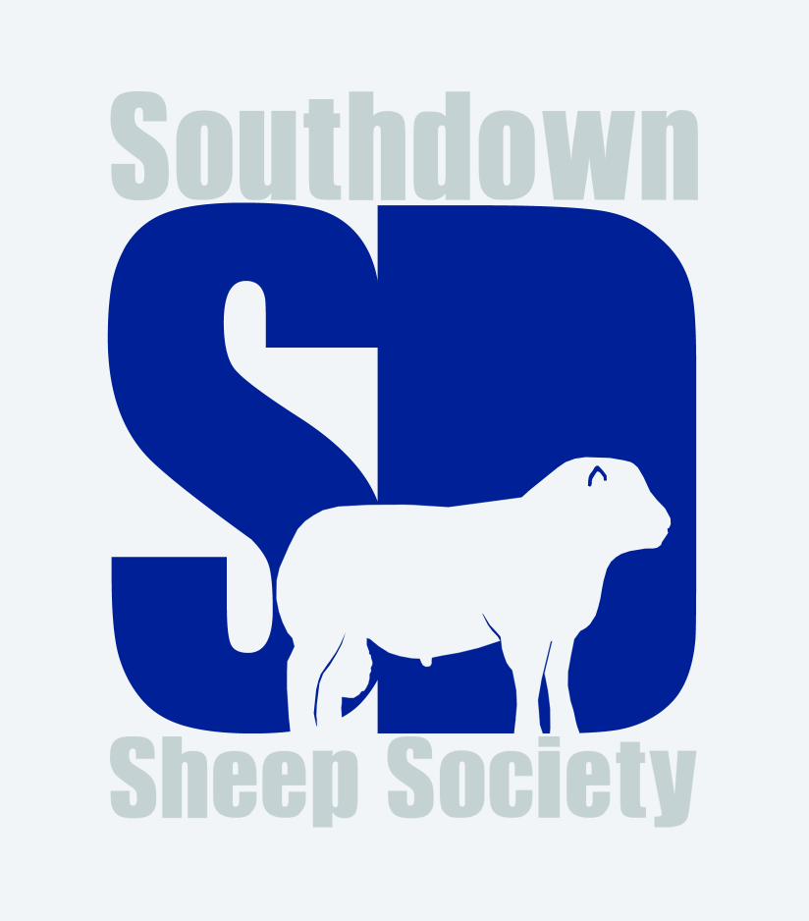

Southdown Sheep Society Council meeting: Wednesday 30th October 2019 at 10.30am
Board Room, at RBST, Stoneleigh Park, Kenilworth
Minutes

Those present:
Sid Cook (SC)
Duncan Crundwell (DC)
Lindsay Dane (LD)
Patrick Goldsworthy MBE (PG)
Edward Harmer (EH)
Justin Harmer (JH)
Paul Humphrey (PH)
Stephen Humphrey (SH) Jonathan Long (JL)
Tim Morris (TM)
Nick Page (NP)
Miriam Parker (MP)
Les Newman (LN) President Elect
Michael Sprake (MS) President
Neil Stainthorpe (NS) Hon. Treasurer
` Howard Wood (HW) Vice Chairman

Gail Sprake (GS) Secretary

Agenda Item | Action by | Due by
1. Welcome, apologies, and declaration of interests
The President welcomed all to the meeting.

Apologies: Adam Brown
Declarations of Interest: Council members were reminded that should interests change they are required to inform the secretary.
2. Election of Officers
Chairman
1 nomination: J Long, proposed by H Wood, seconded by M Sprake
On a vote: 14 for, 2 abstentions.

Vice Chairman
1 nomination: H. Wood, proposed by J Long, seconded by D Crundwell
All in favour

Additional appointments:
NSA representatives: J Long & S Humphrey
South Downs National Park Authority representative: D Burden

3. Minutes of Council meetings:
24th April 2019
Proposed by TM, seconded by MS. 14 for, 2 abstentions
1st August 2019
Following one amendment: Vice Chairman not Chairman opened the
Meeting, proposed by LD, seconded by PG, approved unanimously
7th September 2019
Proposed by HW, seconded by NP, approved unanimously

4. Matters arising, not covered elsewhere

EH queried method and timing of circulation of Minutes for approval. To be considered under Item 13.
5. Devon County Show  The Chairman explained briefly the issues relating to Devon County Show and the appointment of Anne Lambert as judge of 2020 Southdown classes.  The Vice Chairman read to Council a letter from Adam Brown in which he tendered his resignation from Council at this point and recognized that his actions were inappropriate. Devon County Show to be informed that Mrs Lambert should be invited to judge the 2021 Southdown classes at the Show. | Chairman to contact Devon County Show office. | Early November
6. Update on issues relating to Worcester Sale 2018  JH & EH were asked to stand out during initial discussion. HW & A Brown had received written requests from Susan Harmer regarding arbitration. Council agreed that the allegations against the secretary had been considered, noted as unfounded and the matter closed. It was agreed to invite EH & JH to rejoin the meeting to clarify the purpose of requested arbitration.  Following discussion, the following motion was put forward: “All to agree to disagree on the matter. A line to be drawn under the whole situation and all to move forward”.  Proposed by HW, seconded by SC  On a vote: 14 in favour, 2 abstentions | EH & JH to consult with Susan Harmer regarding the proposal and to make contact with JL regarding her agreement to this. | Nov 1
7. Financial Matters  i) The Treasurer offered the financial report.  To date: expenditure totals £39,873, income totals £17,852.  The current a/c balance stands at £4169, the Business Reserve a/c £3594.  Legal fees currently total £17,554. With the exception of the expenditure on legal fees, the 2019 expenditure currently totals £22,319, compared with total expenditure for 2018 of £24,274.  The majority of income for remainder of year is now due from registrations and membership subscriptions.  ii) Investments  CCLA fund totals £3006, Cambridge & Counties fund totals £40,207.  Interest accrued to date on investments totals £723, an increase on 2018.  iii) Appointment of Auditors for financial year 2019: Lovewell Blake  proposed by JL, seconded by JH. All in favour.  iv) 2020 Budget  LN presented the draft 2020 Budget:  Income: membership subscriptions have increased, registrations currently  down, a trend in line with other breed societies. Remaining income as per  2018.  Expenses: Mostly in line with budget and comparable with 2018. But expenditure of £19000 on legal fees has made a hole in the original budget and in Society reserves. It was hoped that this could be eliminated for 2020.  LN to finalise 2020 Budget once final income figures available at year end. He stressed that the 2020 target should be to break even. | Accurate draft Budget to be circulated to Council members via email | Mid January 2020
8. New members were approved

Neil Fisher, Mark Kemp & Ursula Lewis, Joshua Farrell, Coral Hannah Bent, Paul Taylor, RJ & C Windsor, Lee-Anne Skipper, Sarah-Jane Thompson, Nick Page, Miss Rose Hargreaves, Mrs J Wakeham-Dawson & Miss A Harmer, Daffyd & Deian Williams, S Abbott & D Dunstan, Liam Jefferson, Alan D Manton, Deborah Cox, P E Goldsworthy MBE (Heritage Flock), D Whitcher-Christmas, J & R Mitchell, Rebecca Neal, Sue Woods, Messrs Watton, IM & HB Jackson, Mathilde Hallifield, Keri Strugnell.

9. Developing an up-to-date strategy  MP re-presented paper, previously circulated, which generated considerable discussion.  Three immediate actions were highlighted:  i) agreement that a strategy is needed  ii) consideration of a time line  iii) review of objects and Articles of Association as ‘fit for purpose’.  The following motion proposed by MP, seconded by PG: “To agree the need for a strategy, to agree a time frame (2020-2025), all future committees to consider strategy.” All in favour. | All committees to consider future strategy within the remit of committee | November 2019 onwards
10. Judging & Showing

i) National Show 2019:
The report and results from the 2019 National Show at Royal Cheshire Show had been published on the website. The ‘tea party’ organised by the West Midlands Group had been well received and thanks were conveyed to MP and her team.
ii) National Show 2020:
Royal Welsh Show to host 2020 National Southdown Show, judge is J Long.
There are no additional classes, but there is facility for MV Accredited sheep for 2020. The limitation on penning and all usual RWAS rules will still apply.
Following discussion it was confirmed that whilst a members’ ‘get-together’ post judging, with refreshments, would be welcomed, there are no additional facilities to fund this. It is hoped that the Welsh Breeders’ Group could organise this privately on behalf of all exhibitors, using the West Midlands Group as an example.
iii) 2020 judging appointments:
The following judging appointments were discussed and agreed:
South of England: judge G L Hughes, proposed by SH, seconded by EH. All in favour.
Royal Three Counties: judge S Humphrey, proposed by JL, seconded by JH. All in favour.
Cheshire: judge C Brown, proposed by JH, seconded by HW. All in favour.
2020 Flock Competition: A Glaves, proposed by HW, seconded by DC. All in favour. Reserve: C Brown, proposed by JL, seconded by HW. All in favour.
Worcester Show & Sale: judge N Page, proposed by JL, seconded by HW. All in favour.
Melton Mowbray Show & Sale: judge T Rowlands, proposed by LD, seconded by MS. All in favour.
SEAS had submitted changes to the schedule of classes for 2020. These were noted.

11. Communications

i) 2020 Year Book:
Following discussion it was confirmed that the Year Book is the Society’s major outward-facing publication which is useful and good value. Advertising costs almost cover cost of printing. Fewer articles and lower grade paper could reduce costs. The twice-yearly newsletter is inward-facing, produced for members.
ii) Advertising rates for 2020:
Following discussion, advertising rates to remain as per 2019.
Proposed by NS, seconded by SH. All in favour.
All to make an effort to encourage external advertisers.
Sealed bids: PG proposed, seconded by SH, that the sealed bids for prime pages be repeated for 2020 publication. On a vote: 13 for, 2 abstentions, 1 against. To be publicised in forthcoming newsletter.
iii) eNewsletters:
Newsletters: Agreement that these provide a useful service. Currently, 37 members do not have email contact. Following discussion, it was agreed that the biannual paper newsletter is well received and a change to electronic-only newsletters would at present be inadvisable. These would continue to be complemented by separate, shorter eNewsletters as required.
iv) Marketing & Advertising, 2019 analysis:
- The full breakdown of expenditure was considered. The Publicity & Communications committee will give further consideration to the annual advertising strategy. It was agreed not to advertise in the January 2020 Farmers Guardian Breed Directory. It was confirmed that RWAS would not permit banner displays within the sheep lines for welfare/ventilation reasons.
12. Management Structure  The Chairman introduced the paper previously circulated, regarding proposed management structure to be underway with immediate effect.  Three committees to be set up as follows:  - Finance Committee: Chairman NS; members SC, JH, PH, LN and MS  - Show & Sales Committee: Chairman JL; members DC, SH, NP, MP, PG (PG to attend for one year only)  - Publicity & Communications Committee: Chairman HW; members LD, PG, EH, TM  Considerable discussion ensued regarding composition of membership of sub-committees and the need for transparency in any co-option process. Clarity needed as to how members should be co-opted to a committee, in order to avoid criticism of ‘cronyism’. The Chairman advised trialling the structure as presented until the 2020 AGM, when the structure could be re-assessed and modified if necessary. There is an opportunity for further consideration at the April 2020 Council meeting. No co-options to take place until after the next Council meeting. Each committee to take responsibility for own Minute taking to enable Society secretary to ‘float’ between committees as required.  It was highlighted that whilst Council was not fully representative of the membership, all members have equal opportunity to stand for Council.  The Chairman stressed that it was imperative that all committees commenced work immediately in order to bring proposals to the April meeting for ratification by Council.  In addition, a Task & Finish Group to be set up to consider all aspects of Governance, including review of current Articles of Association, Standing Orders and Rules. Chairman: President; members to comprise office holders JL, NS & HW, plus LD & EH. The aim is to present the updated Articles to membership at the 2020 AGM for approval.  The management structure was proposed by JL, seconded by TM. All in favour.  Committees to organise their own meetings, making use of electronic facilities. It was pointed out that not all areas of UK have reliable internet signal. All agreed that it was vital for the Society to have available clear, effective, good value telephone conference facilities, with Society to cover cost of such facilities. Other electronic means of communication also to be considered. | JL, NS, HW, MS  Committee chairmen to organise their respective committee and arrange necessary meetings with committee members  Secretary & TM to investigate conference call facilities  HW & Publicity & Communications committee | October 31st onwards  October 31st onwards
13. Publication of Minutes  Council members agreed that greater transparency would be beneficial. One set of Minutes to provide an accurate record of the Council meeting, to be published on the Society website once considered and approved at the following Council meeting. Concern was raised regarding the lapse of time between the meeting and the publication of the approved Minutes. It was agreed that a brief eNewsletter should be produced promptly, within two weeks of the Council meeting, then a more detailed report to be included in November paper newsletter to all members.  Proposed by JL, seconded by EH. All in favour. | Chairman to produce brief eNewsletter covering major points of Council meeting | Nov 13
14. Shows & sales  Both official sales, Worcester and Melton Mowbray, were reviewed.  Discussion ensued regarding the current upset prices, as this was an area of concern for some members. The Show & Sales Committee to review upset prices and weights and to bring recommendations to next Council meeting.  The dates for the 2020 official sales confirmed as follows:  Worcester – August 8th 2020  Melton Mowbray - September 11-12th 2020 | Show & Sales Committee | April 2020
15. AGM

i) Minutes of AGM 2019 previously circulated and amended where necessary.
The Minutes to be mentioned in forthcoming newsletter then published on the website, in draft form.
ii) Points raised at the AGM were debated and considered:
- Judges & Judging: to be considered by the Show & Sales Committee.
Hailsham Sale: organisers to organisers able to purchase advertising space in Society publications as all members can.
- UK numbers and flock identification: After discussion and with due consideration to the implications for all members, it was proposed that all animals born on holdings with more than one registered Southdown flock must be identifiable to their individual flock. This should be done by including the registered flock number or prefix on identification tags. To be in force by January 2021 at the latest, preferably starting in 2020. All in favour.
iii) AGM/Field Day 2020: Confirmation awaited from Shugborough regarding use of venue for 2020. Vice Chairman HW has offered to host for 2020. Date to be confirmed. Secretary to circulate options.

16. 2020 Council meetings

Following discussion it was decided to hold two meetings of Council in 2020, with the option of convening an additional meeting between the April meeting and the AGM.
Two dates confirmed at RBST Head Office at Stoneleigh Park:
April 29th 2020
October 21st 2020

17. 2019 Flock Competition
Full results of the Flock Competition were tabled at the meeting. All 13 participants had been individually informed of the results. The Chairman recorded his thanks to judge Neil Stainthorpe and to all members who had taken part, and he congratulated the winners. Results to be included in newsletter.

18. NSA Matters  A report from the NSA Breed Society Forum on May 2nd had previously been circulated. JL encouraged all Council members to join NSA.  MP made mention of BWMB trial concerning fleeces, details to be forwarded to Southdown office. | MP to forward details to Southdown office.
19. Imports and Exports  The import of three males from France, and the export of three females to Germany, were noted.  Secretary commented that enquiries received from EU and beyond regarding the breed. Previously, article included in newsletter asking for any members interested in exporting to contact the office. Very little interest to date. It was decided to update the article and include in forthcoming newsletter. | Secretary to update export article for newsletter | November
20. Forthcoming events:

The dates of the 2019 Winter Fairs were noted.
21. Regional Groups:  The current contact list was previously circulated as included in newsletter and on website.  Wales Group: would like a stand in NSA Pavilion at Royal Welsh Show, sufficient members available to man the stand. It was agreed in principle to purchase stand space, cost and location tbc.  South of England Group: A Lambert willing to assist PH with group. | NSA Pavilion at RWAS, stand to be booked | Spring 2020
22. Correspondence  i) Death of member Miss S Cartwright noted. A Brown to attend memorial service, secretary to send letter of condolence to family.  ii) Ashford Cattle Show had sent booking form for the Annual Dinner.  iii) D Williams: The Chairman stated that the Southdown Sheep Society could not condone the reported welfare offence. It was confirmed that D Williams had resigned from Council immediately following the issues being made public. He has subsequently resigned as a member of the Society.  iv) S Gamble had asked to change ownership of his flock to his son. Council confirmed that this was in order.  v) Letter from J Middleditch re Lincoln Show incident June 19/20th 2019. A letter had subsequently been received by judge P Humphrey in which he stated a clear recollection of events surrounding the selection of breed pairs at the Lincoln Show. JL to update J Middleditch. | Chairman to contact  J Middleditch | November
23. Any Other Business  i) LN asked for view of Council on mandatory showing of all males entered in to breed society sales linked to shows. Following discussion, it was agreed to leave as is.  ii) LN suggested that entry in to National Show late lamb classes should be restricted to exhibitors showing only late lambs. These classes are not available at the 2020 National Show at Royal Welsh. Issue to be considered by Show & Sales committee.  iii) It was suggested that rosettes could be presented to novice exhibitors and young handlers.  iv) It was suggested that the Show & Sales committee should emphasise the encouragement of grass-fed sheep when considering judging criteria.  v) NFU Trophies: wording to be finalised for trophy engraving. Both trophies to be used to celebrate achievements of younger members (under 21 years), not just in the show ring. Council members to forward suggestions of names to office, trophies to be awarded at year end. | ALL Council members | Early November
CLOSE
The meeting closed at 15.06h

