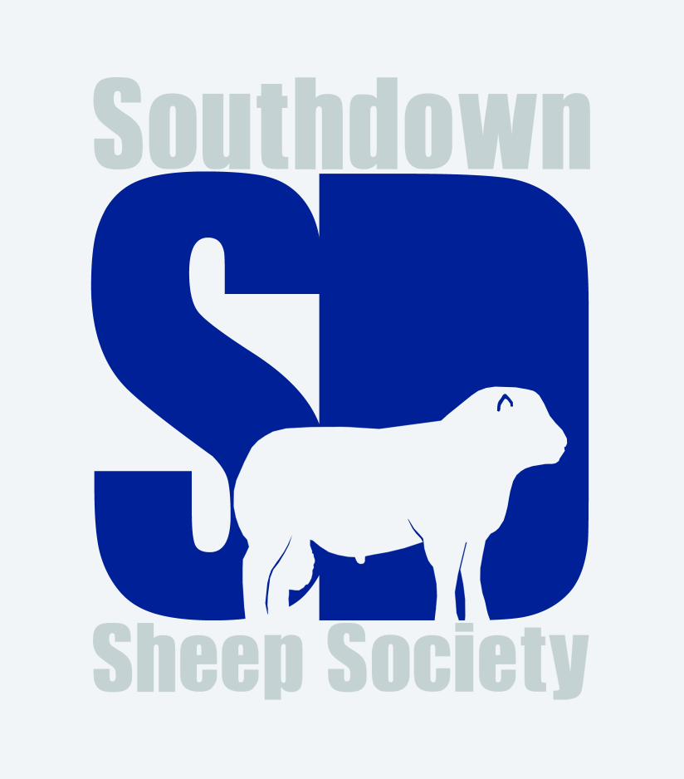

Royal Three Counties Show 2022

Group of Three Lambs
- Jonathan Long
- Basil Cooper

Aged Ram
- Basil Cooper
- Jonathan Long
- J Dickin
- Wowie Dunnings

Shearling Ram
- Basil Cooper
- Jonathan Long
- Wowie Dunnings
Ram Lamb
- Wowie Dunnings
- Basil Cooper
- Sophie Long
- Jonathan Long

Aged Ewe
- Jonathan Long
- Basil Cooper
- Wowie Dunnings
- Sophie Long

Shearling Ewe
- Jonathan Long
- James Leonard and family
- Basil Cooper
- Olivia Holtom
Ewe Lamb
- Jonathan Long
- James Leonard and family
- Basil Cooper
- J Dickin

Champion – Jonathan Long’s shearling ewe
Reserve champion – Basil Cooper’s aged ram

