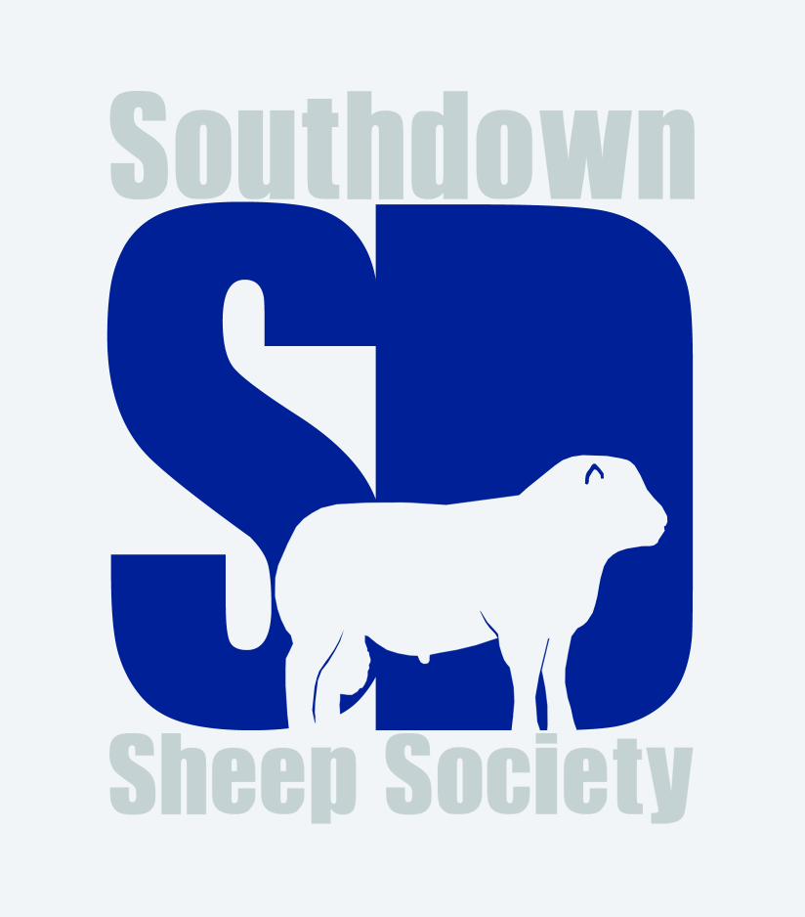

Kenilworth Show 2022

Ram, any age
- J Dickin
- A Watton
- A Watton

Ram Lamb
- C Tester
- J Dickin
- A Watton

Aged Ewe
- C Tester

Shearling Ewe
- O Holtom
- O Holtom
- J Dickin
- O Holtom

Ewe Lamb
- J Dickin
- A Watton
- C Tester

Pair
- O Holtom
- J Dickin
- A Watton

Champion – O Holtom’s shearling ewe
Reserve champion – J Dickin’s ewe lamb

