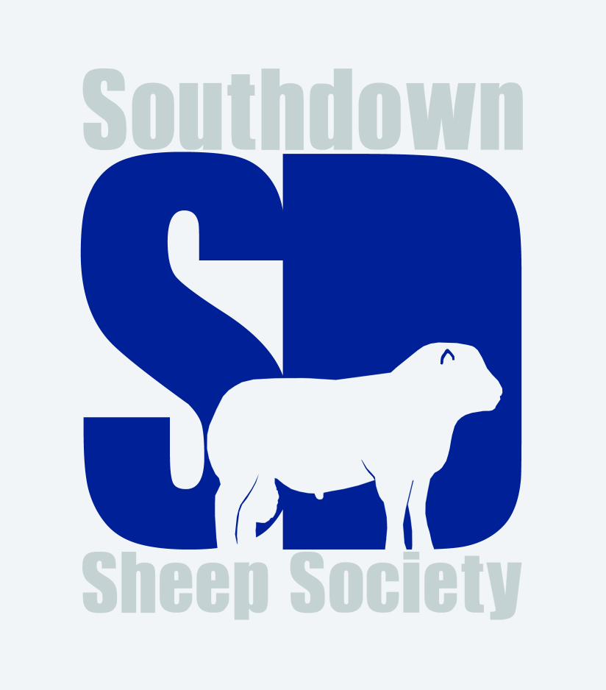

Hanbury Show 2022

Ram Shearling or Older
- Jonathan Long
- Joanna Miller
- Joanna Miller
- J Dickin

Ram Lamb
- Jonathan Long
- Joanna Miller
- J Dickin

Ewe Shearling or Older
- Jonathan Long
- Johanna Miller
- J Dickin

Ewe Lamb
- Jonathan Long
- Joanna Miller
- J Dickin

Group of Three
1 – Jonathan Long
2 – Joanna Miller

Champion – Jonathan Long’s aged ram
Reserve champion – Jonathan Long’s shearling ewe

Interbreed champion – Jonathan Long’s aged ram

