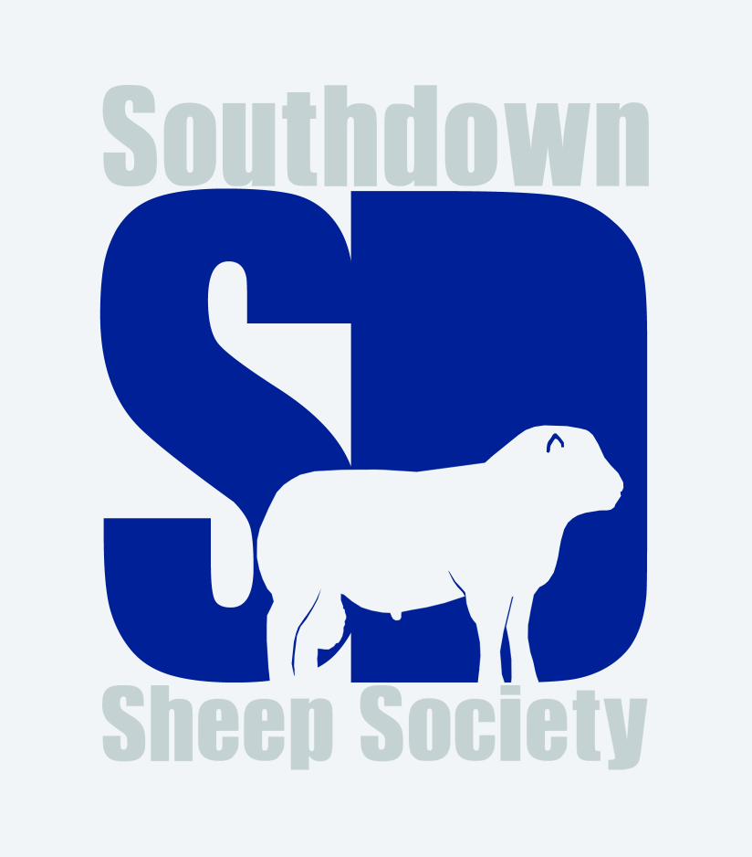

Advertise your flock
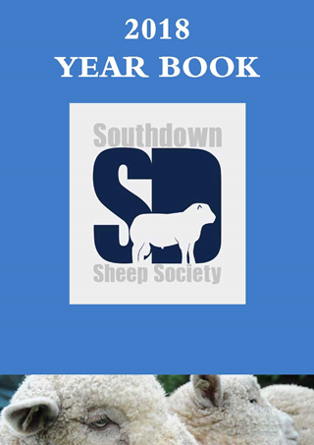
As a member of the Southdown Sheep Society there are a number of ways in which your flock, or individual animals, may be advertised:

2019 YEAR BOOK
The Year Book is the Society’s key outward-facing advertising ”tool” and is distributed widely. The publication is A4 format and in full colour. All adverts included in the Year Book will also be added to the website and your flock will be shown on the interactive on-line map.

Advertising rates for members are as follows:
Full page £80*
Half page £40*
Boxed Adverts (including name, address, flock and contact details) Grouped by Region £10

For the premium pages (centre-pages-double spread, inside front cover, and inside back cover) we are inviting ‘silent bids’. Simply contact the office – by e-mail with your preferred page/s and the bid you wish to place. The closing date/time for receipt of silent bids is midnight December 31st.

*Members purchasing full or half pages will also be listed in the Boxed Adverts for free.

The deadline for advertising copy is January 31st 2019

WEBSITE ADVERTS
Website adverts for stock currently for sale may be placed at any time. The cost of placing an advert on the website is £10 per advert. All adverts will include the flock name, breeder’s contact details including telephone numbers and email, and a brief outline of what is available for sale. Please note that no pedigree information, no show results and no photographs will be included. Adverts remain on the website for 3 months. Please email the office with details. A link to your own website is possible.

